|  |
| --- |
|  |
| 新概念 3 册 |
| Lesson42 Modern cavemen |

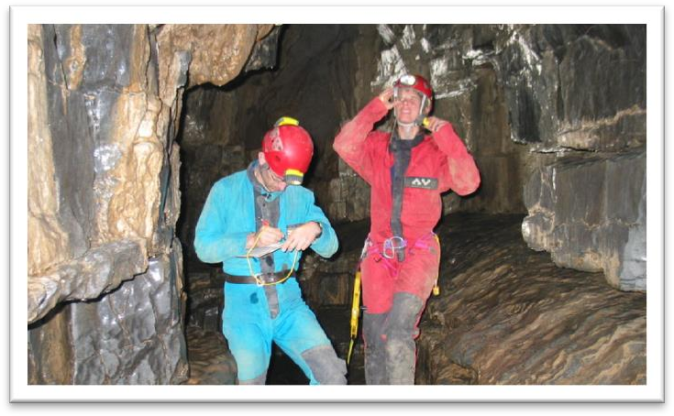

Book

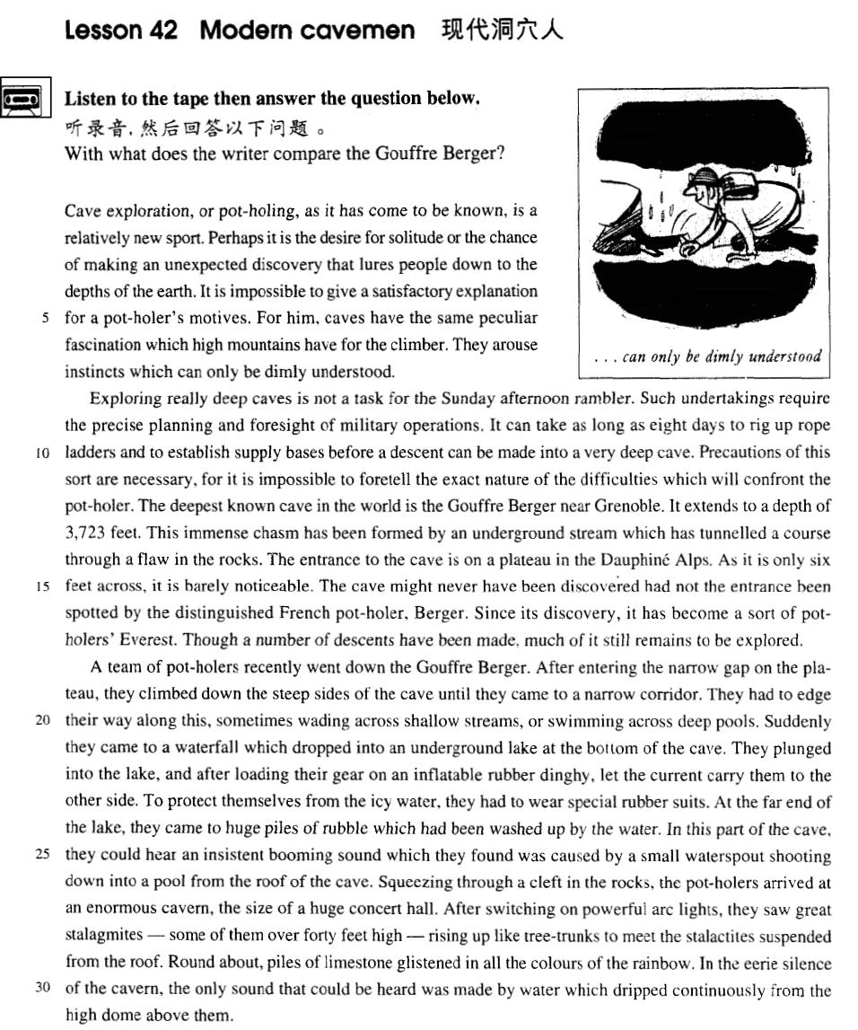

课文

Cave exploration, or pot-holing, as it has come to be known, is a relatively new sport.

洞穴勘查--或洞穴勘探--是一项比较新的体育活动。

Perhaps it is the desire for solitude or the chance of making an unexpected discovery that lures people down to the depths of the earth.

寻求独处的愿望或寻求意外发现的机会的欲望吸引人们来到地下深处。

It is impossible to give a satisfactory explanation for a pot-holer's motives.

要想对洞穴探险者的动机作出满意的解释是不可能的。

For him, caves have the same peculiar fascination which high mountains have for the climber.

对洞穴探险者来说，洞穴有一种特殊的魅力，就像高山对登山者有特殊魅力一样。

They arouse instincts which can only be dimly understood.

为什么洞空能引发人的那种探险本能，人们对此只能有一种模模糊糊的理解。

Exploring really deep caves is not a task for the Sunday afternoon rambler.

探测非常深的洞穴不是那些在星期日下午漫步的人所能胜任的。

Such undertakings require the precise planning and foresight of military operations.

这种活动需要有军事行动般的周密布署和预见能力。

It can take as long as eight days to rig up rope ladders and to establish supply bases before a descent can be made into a very deep cave.

有时需要花费整整8天时间来搭起绳梯，建立供应基地，然后才能到一个很深的洞穴里。

Precautions of this sort are necessary, for it is impossible to foretell the exact nature of the difficulties which will confront the pot-holer.

作出这样的准备是必要的，因为无法预见到洞穴探险者究竟会遇到什么性质的困难。

The deepest known cave in the world is the Gouffre Berger near Grenoble.

世界上最深的洞穴是格里诺布尔附近的高弗.伯杰洞，

It extends to a depth of 3,723 feet.

深达3,723英尺。

This immense chasm has been formed by an underground stream which has tunnelled a course through a flaw in the rocks.

这个深邃的洞穴是由一条地下暗泉冲刷岩石中的缝隙并使之慢慢变大而形成的。

The entrance to the cave is on a plateau in the Dauphine Alps.

此洞的洞口在丹芬阿尔卑斯山的高原上，

As it is only six feet across, it is barely noticeable.

仅6英尺宽，很难被发现。

The cave might never have been discovered had not the entrance been spotted by the distinguished French pot-holer, Berger.

若不是法国著名洞穴探险家伯杰由于偶然的机会发现了这个洞口的话，这个洞也许不会为人所知。

Since its discovery, it has become a sort of pot-holers' Everest.

自从被发现以后，这个洞成了洞穴探险者的珠穆朗玛峰，

Though a number of descents have been made, much of it still remains to be explored.

人们多次进入洞内探险，但至今尚有不少东西有待勘探。

A team of pot-holers recently went down the Gouffre Berger.

最近，一队洞穴探险者下到了高弗.伯杰洞里。

After entering the narrow gap on the plateau, they climbed down the steep sides of the cave until they came to a narrow corridor.

他们从高原上的窄缝进去，顺着笔直陡峭的洞壁往下爬。

They had to edge their way along this, sometimes wading across shallow streams, or swimming across deep pools.

来到一条狭窄的走廊上。他们不得不侧着身子往前走，有时过浅溪，有时游过深潭。

Suddenly they came to a waterfall which dropped into an underground lake at the bottom of the cave.

突然，他们来到一道瀑布前，那瀑布奔泻而下，注入洞底一处地下湖里。

They plunged into the lake, and after loading their gear on an inflatable rubber dinghy, let the current carry them to the other side.

他们跳入湖中，把各种器具装上一只充气的橡皮艇，听任水流将他们带往对岸。

To protect themselves from the icy water, they had to wear special rubber suits.

湖水冰冷刺骨，他们必须穿上一种特制的橡皮服以保护自己。

At the far end of the lake, they came to huge piles of rubble which had been washed up by the water.

在湖的尽头，他们见到一大堆一大堆由湖水冲刷上岸的碎石。

In this part of the cave, they could hear an insistent booming sound which they found was caused by a small waterspout shooting down into a pool from the roof of the cave.

在这儿，他们可以听见一种连续不断的轰鸣声。后来他们发现这是由山洞顶部的一个小孔里喷出的水柱跌落到水潭中发出的声音。

Squeezing through a cleft in the rocks, the pot-holers arrived at an enormous cavern, the size of a huge concert hall.

洞穴探险者从岩石缝里挤身过去，来到一个巨大的洞里，其大小相当于一个音乐厅。

After switching on powerful arc lights, they saw great stalagmites -- some of them over 40 feet high -- rising up like tree-trunks to meet the stalactites suspended from the roof.

他们打开强力弧光灯，看见一株株巨大的石笋，有的高达40英尺，象树干似的向上长着，与洞顶悬挂下来的钟乳石相接。

Round about, piles of limestone glistened in all the colours of the rainbow.

周围是一堆堆石灰石，像彩虹一样闪闪发光。

In the eerie silence of the cavern, the only sound that could be heard was made by water which dripped continuously from the high dome above them.

洞里有一种可怕的寂静，唯一的可以听见的声响是高高的圆顶上不间断地滴水的嘀嗒声。

词汇讲解

* **solitude** ['sɒlɪtju:d] n. 单独, 独自 （没有感情色彩）
* Perhaps it is the desire for **solitude** or the chance of making an unexpected discovery that lures people down to the depths of the earth.
* I love **tranquil** **solitude**. —— P. B. Shelley

**do sth in solitude** 独自的做某事

* I **spent** the morning **in solitude**.
* I live **in** that **solitude** which is painful in youth, but delicious in the years of maturity. —— Albert Einstein

**【同根词】**

**solitary** 单独的；唯一的

* They had a single aim, a **solitary** goal—the top!

**【复习】**

**do sth *all* (alone / on one’s own / by oneself )** 单独的做某事

* **lure** [lʊə(r)] v. 引诱，诱惑

**lure sb. to / into some place** 诱惑某人到某地

* He **lured the victim into** a deserted house.
* Perhaps it is the desire for solitude or the chance of making an unexpected discovery that **lures people down to** the depths of the earth.

**lure sb. into doing** 诱惑某人做某事

= **tempt sb. to do / into doing**

= **entice sb. to do / into doing**

* **foresight** ['fɔ:saɪt] n. 远见, 先见之明
* They **had** the **foresight to** invest in new technology.
* Such undertakings require the precise planning and **foresight** of military operations.

**【扩展】**

**forethought** n. 远虑，提前的思考

* With a little **forethought** many accidents could be avoided.

**forecast** n. 预测，预报

* weather **forecast**

**【同根词】**

**foresee** vt. (foresaw, foreseen) 预见到……

* Bagrit **foresaw** a time when computers would be small enough to hold in the hand, …
* Of course, Leon Bagrit could not possibly have **foreseen** the development of the Internet, …
* The telephone rings and this marks the prelude to an **unforeseen** series of catastrophes.

**【扩展】**

**foretell / predict** v. 预言……

* Precautions of this sort are necessary, for it is impossible to **foretell** the exact nature of the difficulties which will confront the pot-holer.
* Considering how recent these developments are, it is even more remarkable that as long ago as the 1960s, an Englishman, Leon Bagrit, was able to **predict** some of the uses of computers which we know today.
* Timely snow **foretells**（预示着，不能换成predict） a bumper harvest.

**【复习】**

**mark the prelude to sth.** 预示……

* The telephone rings and this **marks the prelude to** an unforeseen series of catastrophes.
* **insistent** [ɪn'sɪstənt] adj. 声音持续不断的；坚持要求的

**含义1：**adj. 声音持续不断的

* the **insistent** ringing of the phone insistent

**含义2：**adj. 坚持要求的

**be insistent on sth.** 坚持某事

**be insistent that + S. + (should) do insist on sth.** 坚持要求做某事

**【同根词】**动词形式

**insist that + S. + (should) do** 坚持要求做某事

* Even though the noble was expected to read the letter at each performance, healways **insisted that** it ***should***be written out in full.

**【扩展】【形近词组】**

**persist in … / with …** 坚持不懈

**persistent** adj. 坚持不懈的

**consist of …** 由……组成

* Though the costume ***consisted*** *only* ***of*** a sheet, it was very effective.

**be consistent with …** 与……符合，前后一致

**resist** v. 抵制，抵抗

**be resistant to sth.** 抗……，反对……

* **6级真题：**

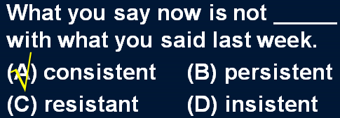

* **glisten** ['glɪsn] v. 闪光，闪烁

**【总结】【复习】** 表达“**闪光、闪烁**”：

**flash** v.& n. （一道刺目的强光，转瞬就熄灭了）

* a **flash** of lightning
* Sparks were emitted from small black boxes and red lamps **flashed** on and off angrily.

**flicker** v.& n. （一般指灯火、烛光等，忽明忽暗的摇曳闪烁）

* The **candle** **flickered** in the wind.
* These lights **flickered** continuously like traffic lights which have gone mad.

**glow** v. & n. （燃烧过的物体，发出的温暖暗红色的光）

* The heated iron bar **glowed**.
* There is something comforting about the warm **glow** shed by advertisements on cold wet winter nights.

**twinkle** v.& n. （星光，断断续续的闪烁）

* **Twinkle**, **twinkle**, little star, like a diamond in the sky. — Jane Taylor

**sparkle** / **glitter** / **glint** v. & n. （露水珠、遍地的黄金等等，碎碎的亮点在闪烁）

* The diamond **sparkled** in the sunlight.
* All that **glitters** is not gold. —— Shakespeare
* Nothing can be compared, he maintains, with the first cockcrow, the twittering of birds at dawn, the sight of the rising sun **glinting** on the trees and pastures.

**glisten** v. （潮湿的物体反光）

* His face **glistened** with sweat.
* Her eyes **glistened** with tears.
* Round about, piles of limestone **glistened** in all the colours of the rainbow.

课文讲解

# （第一段）

# Cave exploration, or pot-holing, as it has come to be known, is a relatively new sport.

**语法分析:**

Cave exploration, or pot-holing（同位语）, ***as*** *it has come to be known（****as****... 方式状语从句）*, is a relatively new sport.

知识点（1）

**语法**：**or** 引出同位语

* Football, **or** soccer, *as it is sometimes called*, is very popular in the world.

知识点（2）

**语法复习**：**as** 引导非限定性定语从句

* Things can go wrong on a big scale, **as** （关系代词，非限定性定语从句，做discovered的宾语） a number of people recently discovered in Parramatta, a suburb of Sydney.
* **As** （关系代词，非限定性定语从句，做explained的宾语） the Commanding Officer explained later, one half of the station did not know what the other half was doing!
* If, **as** （关系代词，非限定性定语从句，做reported的宾语） has been reported, they have protected humans from sharks, it may have been because curiosity attracted them and because the scent of a possible meal attracted the sharks.
* **As**（关系代词，非限定性定语从句，做主语） is so often pointed out, knowledge is a two-edged weapon which can be used equally for good or evil.

**语法**：**as** 引导方式状语从句

* **课文写法替换：**非限定性定语从句
* Cave exploration, or pot-holing, **as ~~(it)~~ has come to be known**, is a relatively new sport.
* The problem, **as** I see *it*（方式状语）, is no big deal.
* The author was brought up in a small village, as *it*（方式状语）is recounted in some of his stories.

知识点（3） Lesson:14、16、38

**come to do** 1.开始做某事；2.逐渐慢慢做某事；3.无意的、意外的、碰巧做某事

* Future historians will be in a unique position when they **come to record**（开始做某事） the history of our own times.
* He soon made a name for himself and **came to be**（逐渐慢慢的） known to the Italians as Giovanni Acuto.
* A body **came to be**（无意的、意外的、碰巧做某事） found under the bridge.

知识点（4）【课文仿写】

* **造句**：H1N1 流感, 或称猪流感 (swine flu), 正如人们逐渐了解的那样，是一种高度传染性(highly contagious) 但可防可控可治 (preventable, controllable and curable) 的疾病。
* H1N1 flu, or swine flu, as it has come to be known, is a highly contagious but preventable, controllable and curable disease.

# Perhaps it is the desire for solitude or the chance of making an unexpected discovery that lures people down to the depths of the earth.

**语法分析:**

Perhaps *it is*（强调句，it is … that…）the desire for solitude or the chance of making an unexpected discovery ***that****（that后面直接跟谓语动词，*被强调的部分是句子的主语*）* **lures** people down to the depths of the earth.

知识点（1）

**注意：**“感情”相关的词汇后面的介词通常用**for**

**desire for ...** 对于…的欲望

**appetite for ...** 对……的欲望；胃口；关于……的食欲

**lust for ...** 对 … 有极强的欲望（尤指性欲）

**longing for ...** 渴望；仰望；对…的渴望

**yearning for ...** 渴望；

**craving for ...**  强烈的愿望；渴望；热望

**hunger** / **thirst** **for ...**  饿/渴

知识点（2）

**the depths of the …** …的深处

* **the depths of the** earth
* **the depths of the** ocean
* **the depths of the** space
* **the depths of the** forest
* **the depths of** despair

知识点（3）【课文仿写】

**语法：**强调句

* **造句**：正是对知识的渴诱使他走进了科学的世界。
* It is the desire *for* knowledge that lures him to the scientific world.

# It is impossible to give a satisfactory explanation for a pot-holer's motives.

知识点（1）

**give a** *satisfactory（令人满意的） / convincing（令人信服的） / logical（合理的） / …* **explanation for sth.** 对某事做出了…的解释

**【相关词组】**表达“…解释…”：

**defy explanation** 无法解释

**owe sb. an explanation** 应该像某人解释

* **老友记**
* I feel like I **owe you an explanation**. I don't ordinarily go around kissing guys at parties.

**【扩展】**表达“…解释…”：句型提炼

**it is impossible to give a satisfactory explanation for …** 谁也无法解释

**it has never been explained why …** 谁也无法解释 （lesson40）

* **造句**：谁也无法解释为何玛雅文明从地球上突然消失。
* **It has never been explained why** Maya civilization vanished from the earth.
* **It is impossible to give a satisfactory explanation for** the disappearance of Maya civilization.

# For him, caves have the same peculiar fascination which high mountains have for the climber.

知识点（1）

**have a / an +** *peculiar（奇特的） / extraordinary（非凡的） / unfailing（无穷的）*  ***+* fascination for …** 对某人有一种…的魅力

* Mars **has an extraordinary fascination for** would-be voyagers. Cats have an unfailing fascination for most people.
* **课后题：**Lesson 9
* 4．Cats have an unfailing fascination ___C___ most people. (1.1)

(a) with (b) to (c) for (d) at

知识点（2）

**语法分析:**

*For him（前置，*fascination后面接定语从句*）*, caves have the same peculiar fascination which high mountains have *for the climber（which...定语从句，修饰*fascination*）*.

* **造句**：书对他有一种独特的吸引力，就像化妆品 (cosmetics) 对他老婆的吸引力一样。
* For him, books have the same peculiar fascination which cosmetics have for his wife.

知识点（3） 总结：“魅力”

* Antique shops **exert a peculiar fascination on** a great many people.

**exert a … fascination on sb.**

**have a … fascination for sb.**

* **造句**：我很喜欢集邮 (stamp collecting)。
* Stamp collecting **exerts a peculiar fascination on** me.
* Stamp collecting **has a peculiar fascination for** me.

# They arouse instincts which can only be dimly understood.

知识点（1）

**dim** / **dimly** 昏暗的/地、朦胧的/地

* Then, squinting his eyes, he said: 'The light is **dim**. Read the letter to me'.

**【总结】【复习】**句型提炼

**sth. can only be dimly understood** 某事很难理解

**it is impossible to give a satisfactory explanation for sth.**

* **造句**：他的行为很难理解。
* His behavior **can only be dimly understood**.
* **It is impossible to give a satisfactory explanation for** his behavior.

# （第二段）

# Exploring really deep caves is not a task for the Sunday afternoon rambler.

知识点（1）复习

语法：表种类

* **Horses *are***useful animals. （复数名词，不加冠词）
* **The horse *is***a useful animal. （定冠词加单数名词）
* **A horse *is*** a useful animal. （不定冠词加单数名词）

知识点（2）句型提炼

**… is not a task for sb. ……**不是某人所能胜任的

* **造句**：出国留学不是懒汉 (lazy-bones) 所能胜任的。
* Studying abroad **is not a task for** the lazy-bones.
* **造句**：做个好老公不是花花公子能胜任的。
* Being a good husband **is not a task for** the playboy.

# Such undertakings require the precise planning and foresight of military operations.

知识点（1）句型提炼

**… require the precise planning and foresight of …** 做某事需要…的规划和…远见

* **造句**：炒股 (speculation in stocks) 需要一个职业投资人的精密计划和远见。
* Speculation in stocks **requires the precise planning and foresight of** a professional investor.

**【复习】**“重大行动”、“大量精心的计划”

* For them this is **a major operation** which **involves considerable planning**.
* 造句：出国留学是一个重大行动，需要大量精心的计划。
* Studying abroad is **a major operation** which **involves considerable planning**.

# It can take as long as eight days to rig up rope ladders and to establish supply bases before a descent can be made into a very deep cave.

**语法分析:**

It（形式主语） can take as long as eight days ***to*** *rig up rope ladders and* ***to*** *establish supply bases（to… 真正主语）* before a descent can be made into a very deep cave（介词短语做状语）.

知识点（1）

**take** （上文“require”的替换） 需要

* The wound will **take**（需要） a long time to heal.
* It **takes**（需要） two people to make a quarrel.
* You’re an idiot! 你是个傻瓜
* *It* ***takes***（需要）*one to know one* ! 你也是
* Anyone can be passionate, but it **takes** （需要）real lovers to be silly. —— Rose Franken

**it takes … to do sth.** 做某事需要…

* **造句**：做一名长跑运动员需要耐力(stamina)。
* **It takes** stamina **to be** a long-distance runner.
* **造句**：反抗 (stand up to …) 老板需要很大的勇气。
* **It takes** a lot of courage **to stand** up to the boss.
* **造句**：照顾一名残疾儿童需要很大的耐心。
* **It takes** a lot of patience **to take** care of a disabled child.

知识点（2）

**rig up**: to make sth. quickly out of whatever you can find 草草做成，草草搭起

* They **rigged up** a shelter using a sheet and some branches.

知识点（3）

**make a descent** = descend （书面语）

* ... before pot-holers can **descend** into a very deep cave.

# Precautions of this sort are necessary, for it is impossible to foretell the exact nature of the difficulties which will confront the pot-holer.

**语法分析:**

Precautions of this sort are necessary, **for** it（形式主语） is impossible ***to****（****to*** *…真正主语） foretell the exact nature of the difficulties which will confront the pot-holer（定语从句）*. （**for**... 原因状语从句，for引导的原因状语从句不能放在主句之前)

知识点（1）

**precaution** n. 预防措施

**fire**（防火） / **safety**（安全） / **security**（安保） / **sanitary**（卫生） **precautions**

**take precautions** 采取预防措施

* The government **took precautions** to prevent the spread of the disease.

**【扩展】**

**take measures** 采取措施

* take effective / drastic measures

知识点（2）Lesson40、Lesson41

**语法：**如果把表示类型的词放在前面，如sort、kind、type，后面的可数名词可以当不可数名词；如果把表示类型的词放在后面，可数名词放在前面时一般用复数

… **of this / that +*sort / kind*** 这种类型的…

* I can’t approve of **things of this sort**.

**this / that +*sort / kind* of …**这种类型的…

* I can’t approve of **this sort of thing**.
* **课文写法替换：**
* **Precautions** of this sort ***are***necessary,
* … **This sort of** precaution **is**necessary,

知识点（3）

**… confront / face sb.** 某人面临的某个问题

**be confronted / faced with ...** （被动）

# The deepest known cave in the world is the Gouffre Berger near Grenoble.

知识点（1）

**known** （过去分词做形容词）已知的

**【总结】【复习】**

**little-known** 鲜为人知的

**unknown** 不知道的

**well-known** 著名的

# It extends to a depth of 3,723 feet.

知识点（1）Lesson17、Lesson26

**weigh …** 系动词，有多重

* The boy **weighs** 50 kilos.

**be … (in weight)** 有多重

* The boy **is** 50 kilos **(in weight).**

**be / stand … high / tall** 有多高

* She **stood** （系统词）three feet high and her hands rested on her hips.
* He **stands** / **is** 1.8m tall.

**rise to a height of …** 高达

* Above the surface of the water, the towers **rise to a height of** nearly 700 feet.

**be … deep / in depth** 有多深

* The hole **is** 2 feet **deep / in depth.**

**extend to a depth of …** 深达

* The platforms **extend to a depth of** over 100 feet under the sea.

**be … long / in length** 有多长

* The bed **is** 2 meters **long / in length.**

**be … wide / across / in width** 有多宽

* The river **is** 20 meters **wide / across / in width**.

# This immense chasm has been formed by an underground stream which has tunnelled a course through a flaw in the rocks.

**语法分析:**

This immense chasm has been formed ***by*** *an underground stream* ***which*** *has tunneled a course through a flaw in the rocks（定语从句内的状语）（****which****...定语从句，修饰course）*. （***by***... 方式状语从句）

知识点（1）

**chasm** n. 深渊，峡谷

* It is a world of red sandy deserts (hence its name — the Red Planet), cloudless skies, savage sandstorms, **chasms** wider than the Grand Canyon and at least one mountain more than twice as tall as Everest.

知识点（2）

**tunnel** v. 开凿隧道；挖地道

# The entrance to the cave is on a plateau in the Dauphine Alps.

知识点（1）地理名词

**plateau** 高原

* the Qinghai-Tibet **Plateau**

**plain** 平原

* the North China **Plain**

**basin** 盆地；凹地；海盆

* the Tarim **Basin**

**savannah** （尤指非洲的）稀树草原

**prairie** 北美草原；新大陆北部草原（美国北部和加拿大）

**grassland** 草原；草地；草场

* the Inner Mongolian **Grassland**

# As it is only six feet across, it is barely noticeable.

# The cave might never have been discovered had not the entrance been spotted by the distinguished French pot-holer, Berger.

**语法分析:**

The cave might never have been discovered（主句；虚拟语气；对过去事实的虚拟） **（条件状语从句倒装，省略if）had not** the entrance **been spotted** by the distinguished French pot-holer, *Berger*.

* **课文正常语序：**
* The cave **might** never **have** been discovered **if** the entrance **had** not been spotted by the distinguished French pot-holer, Berger.

知识点（1）复习：虚拟语气

**语法复习：虚拟语气if从句的虚拟**

1.与现在事实相反

If + S. + did / were, S. + would / should / could / might + do

2.与过去事实相反

If + S. + had done, S. + would / should / could / might + have done

3.与未来趋势相反

If + S.+ should do, S.+ would / should / could / might + do

If + S.+ did / were to do, S.+ would / should / could / might + do （强调及其不肯能）

知识点（2）

**语法：虚拟语气的倒装**（只用于书面语）**；if从句的虚拟语气中，出现were**、**had**、**should可用倒装**；

* 1.与现在事实相反：
* If I **were** you, I would go abroad at once.
* **Were** I you, I would go abroad at once. （倒装）
* 2.与过去事实相反：
* If you **had** come here a little earlier just now, you might have met her.
* **Had** you come here a little earlier just now, you might have met her. （倒装）
* 3.与未来趋势相反
* If it **should** rain tomorrow, you could stay at home.
* **Should** it rain tomorrow, you could stay at home. （倒装）
* 3.与未来趋势相反
* If the sun **were** to rise in the west, I would lend you the money.
* **Were** the sun to rise in the west, I would lend you the money.
* **考研英语：**

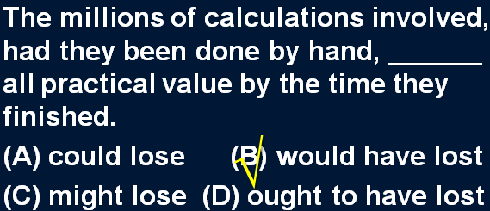

# Since its discovery, it has become a sort of pot-holers' Everest.

知识点（1）

Since （介词）自从

知识点（2） Lesson12、14； 复习比喻

**a sort / kind of ...** 像…一样

* We sometimes imagine a desert island to be **a sort of** paradise where the sun always shines.
* In spite of this, the Italians regarded him as **a sort of** hero.

**【总结】【复习】**Lesson38 “真可谓是”

* They will be able, **as it were**, to see and hear us in action.
* **课文写法替换：**“真可谓是”
* Since its discovery, it has become, **as it were**, the pot-holer’s Everest.
* Since its discovery, it has become, **so to speak**, the pot-holer’s Everest.

# Though a number of descents have been made, much of it still remains to be explored.

知识点（1）

**remain to be done** 有待……

* Several problems **remain to be** settled.
* It **remains to be** seen how many senior citizens will actually benefit from this new plan.

# （第三段）

# A team of pot-holers recently went down the Gouffre Berger.

# After entering the narrow gap on the plateau, they climbed down the steep sides of the cave until they came to a narrow corridor.

# They had to edge their way along this, sometimes wading across shallow streams, or swimming across deep pools.

**语法分析:**

They had to edge their way along this, sometimes wading across shallow streams, or swimming across deep pools.（伴随状语，包含两个非谓语动词）

知识点（1）复习

**edge one’s way** 侧着身走

**squeeze one’s way** 侧身、挤着往前走

**squeeze through / in / past / by ...** 挤进去、过去

* **Squeezing through** a cleft in the rocks, the pot-holers arrived at an enormous cavern, the size of a huge concert hall.

**make one’s way** 朝某地走去 （Lesson36）

* The hospital had been bombed and Hans had made his way back into Western Germany on foot.

**find one’s way** （Lesson15）1.（事物做主语）到达某个地方；2.（人做主语）找到路

* Very few of the fifty pence pieces and pound coins I have given him have **found their way** there.
* They had mysteriously **found their way** there from the wine cellar!

**trace / weave / wind one’s way** （Lesson48）蜿蜒前进

* We expected the path to end abruptly, but we found that it **traced its way** through the trees.

**force / elbow one’s way** 人群中挤过去

**feel one’s way** 摸索着前进

**tunnel one’s way** 挖掘隧道前进

# Suddenly they came to a waterfall which dropped into an underground lake at the bottom of the cave.

# They plunged into the lake, and after loading their gear on an inflatable rubber dinghy, let the current carry them to the other side.

**语法分析:**

They plunged into the lake, *and* after loading their gear on an inflatable rubber dinghy（时间状语）, (they 并列) let the current carry them to the other side.

知识点（1） Lesson10

plunge into … “扑通”跃入水中

* The order to abandon ship was given and hundreds of people **plunged into** the icy water.

# To protect themselves from the icy water, they had to wear special rubber suits.

# At the far end of the lake, they came to huge piles of rubble which had been washed up by the water.

# In this part of the cave, they could hear an insistent booming sound which they found was caused by a small waterspout shooting down into a pool from the roof of the cave.

**语法分析:**

In this part of the cave（地点状语), they could hear an insistent booming sound ***which*** *they found was caused by a small waterspout (shooting down into a pool from the roof of the cave)*. （**which**... *嵌入式定语从句*，既修饰sound，又做*they found*的宾语）

知识点（1）

**语法**：嵌入式定语从句；本身是定语从句修饰先行词，另一方面又是主谓结构的宾语

* 造句：她有一个养子，这个养子据她讲是个孤儿。
* She has an adopted son who *she says* is an orphan.

造句：Aleko 突然得到了一只新的羊羔，这只羊羔他声称是买来的。

Aleko suddenly acquired a new lamb which *he claimed* was bought.

***page197. 课后注释有误***

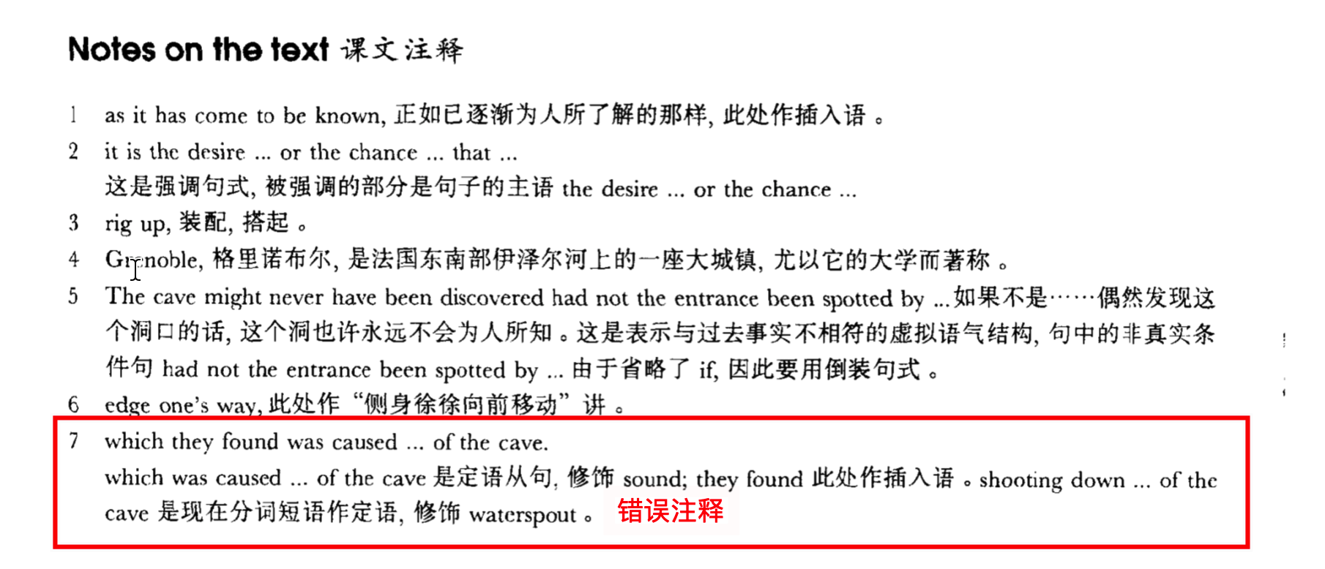

备注：插入语去掉之后应对语法没有影响，也对句子含义也没影响

* He’s just published an article which *I don’t think* is interesting at all. （如果去掉“*I don’t think* ”对句子含义有影响）
* I met a man whom *I thought* was a lunatic. （如果去掉“*I thought*”对语法有影响）

# Squeezing through a cleft in the rocks, the pot-holers arrived at an enormous cavern, the size of a huge concert hall.

# After switching on powerful arc lights, they saw great stalagmites -- some of them over 40 feet high -- rising up like tree-trunks to meet the stalactites suspended from the roof.

**语法分析:**

After switching on powerful arc lights（介词短语做时间状语）, they saw great stalagmites —*some of them over forty feet high（插入语，独立主格）*— **rising** up like tree-trunks to meet the stalactites **suspended** from the roof（**suspended**…过去分词短语做后置定语,修饰stalactites）.（**rising**… 非谓语动词做后置定语,修饰stalagmites）

知识点（1）

**switch on ↔ sth.** 打开开关

**switch off ↔ sth.** 关闭开关

知识点（2）复习：独立主格

... — some of them （being） over forty feet high — ...

知识点（3）【课文仿写】

* **造句**：在打开灯之后, 我看到在一个小黑盒子里面装着闪闪发光的 (sparkling) 钻石, 其中有些有玻璃球 (marbles) 那么大。
* After switching on the light, I saw sparkling diamonds—some of them as big as marbles—contained in a small black box.

# Round about, piles of limestone glistened in all the colours of the rainbow.

# In the eerie silence of the cavern, the only sound that could be heard was made by water which dripped continuously from the high dome above them.

**语法分析:**

In the eerie silence of the cavern, the only sound **that** could be heard was made by water *which dripped continuously from the high dome above them（****which****...定语从句，修饰*water*）*. （**that**...定语从句，修饰sound）

知识点（1）【课文仿写】

* **造句**：在这栋房子可怕的寂静中, 唯一能听到的声音就是从一扇打碎的窗子不断吹进 (blow) 的风声。
* In the eerie silence of the house, the only sound that could be heard was made by wind which blew continuously from a broken window.